ESL Services for Elementary Students
Marcy S. Ogden, ESL Teacher Specialist
M.A. Applied Linguistics, TESOL from Old Dominion University, Norfolk, VA 2001
B.A. International Studies, Spanish from Virginia Tech University, Blacksburg, VA 1998

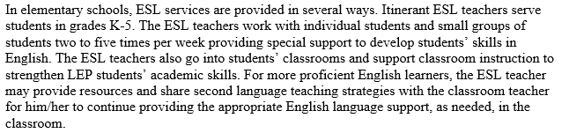
Information in the paragraph above is from VBCPS Parent Notification Letter.
ESL Teacher Specialists in elementary schools do not give grades on report cards. I keep a file portfolio of work completed by your child. Currently, I service Landstown Elementary, Red Mill Elementary & Ocean Lakes Elementary for 2015-2016 school year.

The best way to reach me is by appointment only. Email is the best way to contact me to make an appointment.

I work in multiple schools in Virginia Beach City Public Schools. I am only scheduled at LMS for the Grade 6 elective bell, 11:10-12:00 daily. My schedule changes at elementary schools based on students’ needs.
Email: marcy.ogden@vbschool.com
Phone: 757-648-4750, voicemail # 71488, Landstown Middle School
Phone: 757-648-2880, Landstown Elementary
Phone: 757-648-3560, Red Mill Elementary
Phone: 757-648-3200, Ocean Lakes Elementary

